Module 9

Assignment 9.2
Course: CSD402-340A Java for Programmers
Prepared By: Mirach Erkol
Date of Report: 2/28/2026

https://github.com/Mikey5007/csd-402.git

9.2 Assignment: Correctly Handling Bad User Input
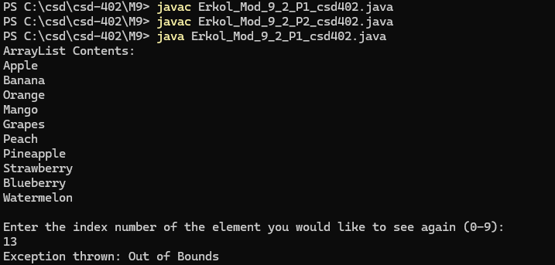9.2 Assignment: Appending an Existing File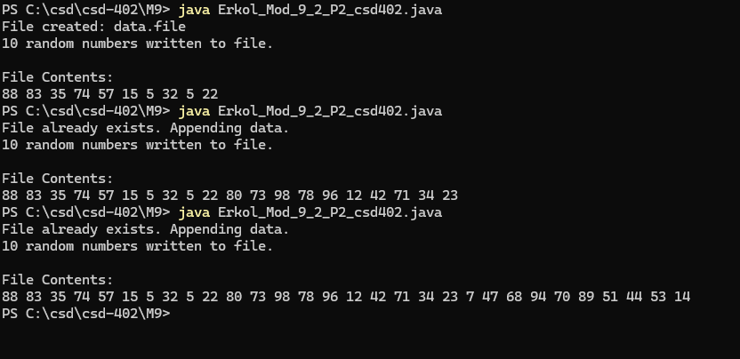

References:

https://github.com/Mikey5007/csd-402.git

